# UNIVERSITY MODEL REPORT

# OBJECTIVE:

The goal is to develop and maintain a performance assessment system that will help universities assess the quality of education they provide to their students.

# ABSTRACT:

The aim of this project is to assess the university's success by collecting feedback from students on classes, teachers, and personal growth and feeding it into a framework that will measure the criteria that the university should concentrate on.

# DESCRIPTION:

A good university is one that provides students with high-quality education that will help them develop a successful career. A university is responsible for providing students with valuable tools that will allow them to succeed.

A University has many constituents, the most important ones are:

1. The Colleges and students associated with the University,

2. The administration which includes workers at different levels.

3. The Universities status in the education world and the responsibility of handling the quality of education and their success rate.

Though many universities are trying to impart best quality education to their students, they aren’t able to produce successful career stories.

It is indeed like a chain reaction every event is dependent on each other, i.e. A good university imparts better quality education to a student, the student is able to make the most out of the resources at his disposal and builds a successful career, this enhances the reputation of the university in the industry and which will raise the bar of the university and the university will make the necessary changes to improve their education and also tie up with the companies in various industries to give the students a better perspective and so more students will become successful using these resources.

It is important for a university to keep track of its students' success and accomplishments because the standard of education offered by the university is what makes the student succeed. A university can be in touch with its former students through every available channel like Facebook, LinkedIn, career blogs. When a university is related to an alumni, it demonstrates how much the university cares about the individual's growth.

The University has an education system in place with different projects associated with each course, but the effect of each course on each person is unknown. Exam results can be used to determine this. Another way to increase education quality is to ensure that students recognize the significance of a specific course in the current industry and the associated criteria. A university should devote few resources to maintain track of its students across different channels,

and in the event that their designations or profiles change, the university should store this information in its own database.

Keeping record of their former students' success and progress would allow them to assess how a certain faculty and course of study supported the student in achieving that success (promotion) and how they can improve it further to improve their students' success rate.

Since most students use LinkedIn to develop their professional profiles, a university may use its tools to track down any of their students' activities by requiring them to join an alumni community at their school and continue to share their accomplishments and papers in order for the university to keep track of their advances.

A university should identify its Key Performance Indicators, to track the progress of former students over time, which can include two years of course completion and five years of work experience.

This above digital idea should not be restricted to universities, in fact it will be more useful if this idea is incorporated all the way from kindergarten to high school.

As schools are smaller organizations it will be easier to keep an eye on the performance of school , teacher and students from a very early age.

And in future by making this a centralized portal where the data is under the government it will be easier to scout talents in studies , sports and work. And every organization can authenticate or cross verify the data with the government.

# Flow:

1. Students will take a bunch of courses and would be graded for each.
2. Average of the GPA of all the students would be calculated.
3. Student, Faculty and University directories would be maintained.
4. Average rating of all the faculties of a particular university would be calculated.
5. Average salary of all the students would be calculated.
6. On the basis of average student GPA, average faculty ratings and average student joining salary, ratings of the universities would be calculated.
7. On the basis of the university ratings, the university rankings would be calculated.

# DIAGRAM

1. SEQUENCE DIAGRAM

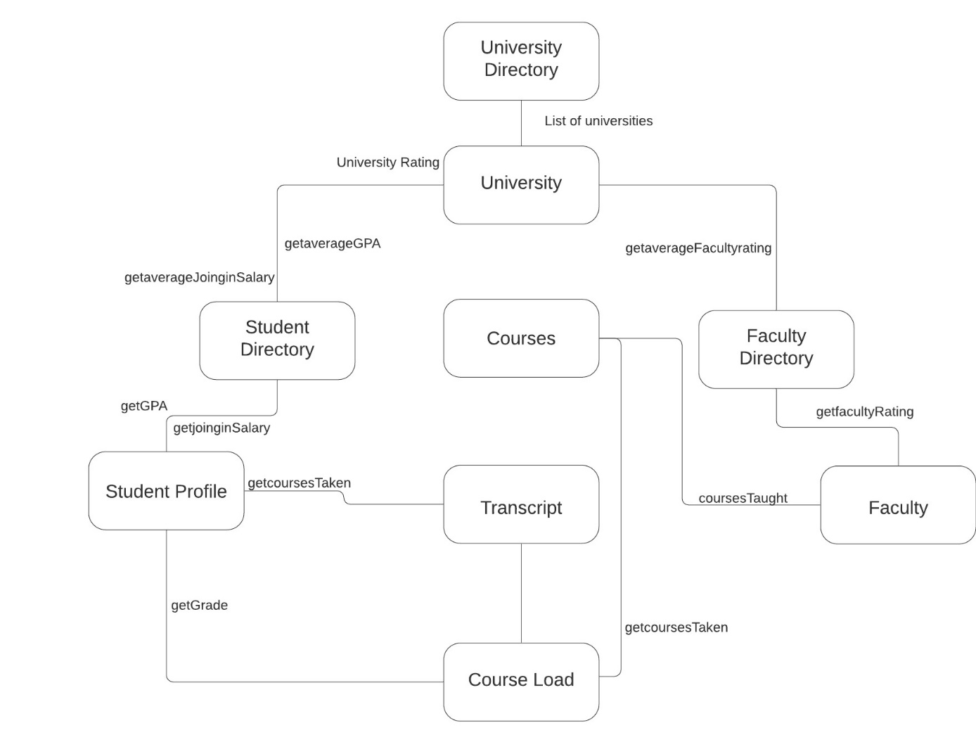

# Contributors:

# Aishwarya Balyaya

# Apurva Nehru